**Table of Content for  
The Project Plan**

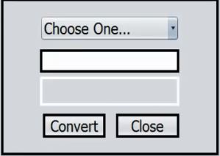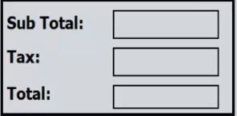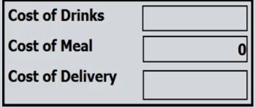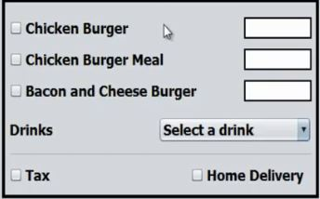**1. Project Resources :**  
1.1 The restaurant staff is our customer.  
1.2process description.

**3. panel to calculate entire cost including tax.**

**2. panel To calculate the cost.**

**1**. **-** **enter number of meals.** -**select a drink ,tax , home delivery.**

1.3 Technologies: Java programming language .

**6. Buttons to execute some functions.**

**5. here is a panel to show the receipt and calculator.**

**4. panel to convert price**

Tools: NetBeans .

**2.Prouduct /Study Dairy :**

2.1 Roles and Responsibilities

🡪 **Awatef Ahmed:** The ScrumMaster , Programmer, panel to enter meals .

🡪 **Salma Ahmed :** Programmer , designer , panel to calculate the price of meals .

🡪 **Sara Ali :** Programmer , tester, panel to panel to calculate the whole price including tax .

🡪 **Donia Ashraf** : Programmer , designer, panel contains an external calculator .

🡪 **Salma Ibrahem :** Programmer , tester , panel to convert price to alternative ones .

🡪 **Mariam shaheed :** Programmer, panel to view the receipt and buttons to execute functions .

2.2 Sprints

**Sprint 1 :** Project set-up and roles assigned.

**Sprint 2 :** creating panels and design.

**Sprint 3 :** adding code to make it work .

**Sprint 4 :** **-** test the entire program .

**-** see the user's opinion and if the user want some modifications .

**3. Risk Management Plan :**

3.1 personnel and group risks .

3.1.1 personnal risk

Team member is sick , face some difficulties , etc .

3.1.2 Group risk

Some problems between team members .

|  |  |
| --- | --- |
| Events | Schedule |
| Project set-up and roles assigned. 1st Sprint. Reserved sprint review meeting for Sprint1. | **ByThu22.2**  **Thu1.3. – Wed14.3.**  **ByFri6.3** |
| Sprint review meeting for Sprint1. 2nd Sprint. Reserved sprint review meeting for Sprint2. | **ByFri9.3-Sun11.3**  **Thu15.3. – Wed28.3.**  **ByTue20.3** |
| Sprint review meeting for Sprint2. 3rd Sprint. Reserved sprint review meeting for Sprint3. | **ByFri23.3-Mon26.3**  **Thu29.3. – Wed18.4.**  **ByFri6.4** |
| Sprint review meeting for Sprint3. 4th Sprint. Reserved sprint review meeting for Sprint4. | **ByTue10.4-Sun15.4**  **Thu19.4. – Fri18.5.**  **BySun22.4.** |
| Sprint review meeting for Sprint4. Presentation of the project. | **Thu26.4. – Sun29.4.** **Thu10.5.** |

**Project Schedule**